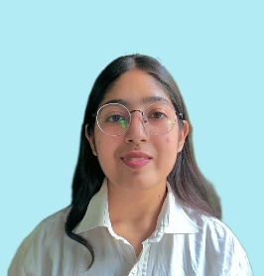**Karishma**

Karishmariya766@gmail.com | (+91) 8267826631

<https://github.com/karishmasagar16> <https://www.linkedin.com/in/karishmasagar2003>

**Objective**

As a recent BCA graduate with a strong foundation in HTML, CSS, JavaScript, C, C++, Core Java, computer network and project management, I am seeking a challenging position to leverage my technical skills, problem-solving abilities, and passion for technology.

**Technical Skills**

* **Programming Languages:** C, C++, core Java, JavaScript, SQL
* **Web Development:** HTML5, CSS3, Bootstrap, Sass
* **Relevant coursework:** Data Structures and Algorithm, Database Management System and Networking.
* **Database:** MySQL
* **Tools:** Git & GitHub
* Proficient in basic and advance knowledge of computer and system management.

**Education**

* Bachelor of Computer Application from IP (PG) College, Campus-2, Bulandshahr, Uttar Pradesh, 203001 in 2021-2024.
* 12th (PCM) from UP Board in 2021 with 80%.
* 10th from UP Board in 2019 with 82.6%.

**Projects**

* **Simon Says Game:**

**Key Technology:** HTML5, CSS3, JavaScript

**Brief Description:** This is primarily a pattern remembrance game. This game is in such a way that there are four boxes. Each box is a different colour. The game starts with a "Press any key to play" heading.

* **UI clone of Netflix:**

**Key Technology:** HTML5, CSS3, Bootstrap

**Brief Description:** Designed a UI clone of the Netflix website.

* **UI clone of Café Era:**

**Key Technology:** HTML5, CSS3

**Brief Description:** Designed a UI clone of the café website.

**Certification**

* Advance information technology & system management in Jan 2018 – May 2019.
* C programming in 01-jul-2022 to 31-aug-2022.
* Data Structure & C++ in 01-oct-2022 to 31-jan-2023.